CTE PROJECT: A SIMPLE TRADING STRATEGY(RESULTS)

Metrics for Golden Cross strategy applied over Adani Power:
1. no of wins = 2
2. no of losses = 2
3. win% = 50%
4. loss% = 50%
5. win percentage returns (total returns we got in all stocks combined) = 7659.94
6. loss percentage returns (total returns we got in all stocks combined) = -11012.37
7. avg returns for winning trades = 3829.97
8. avg returns for losing trades = -5506.18
9. max drawdown = -30.29%

Plot:
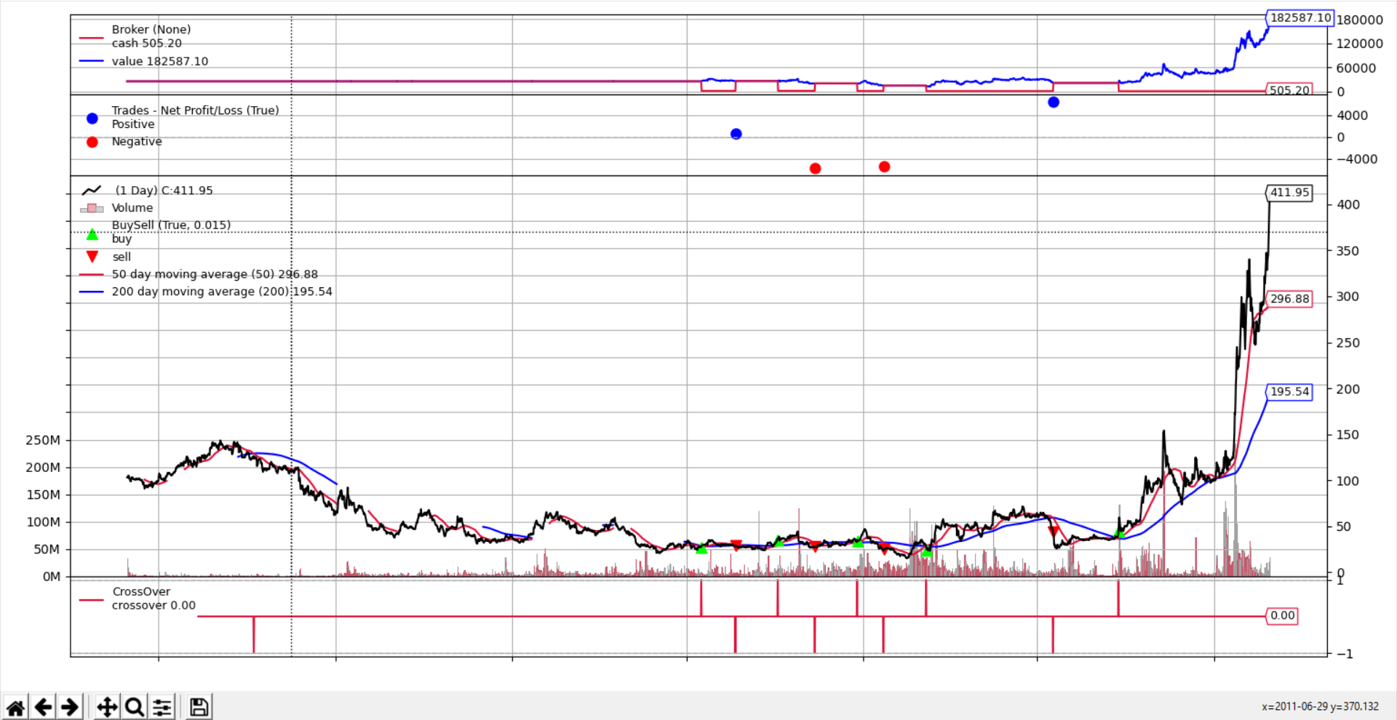
Trades executed:
Buy 863 shares of ADANIPOWER at 27.5
Sell 863 shares of ADANIPOWER at 28.35
Buy 675 shares of ADANIPOWER at 36.150002
Sell 675 shares of ADANIPOWER at 27.549999
Buy 543 shares of ADANIPOWER at 34.799999
Sell 543 shares of ADANIPOWER at 25.200001
Buy 468 shares of ADANIPOWER at 29.299999
Sell 468 shares of ADANIPOWER at 44.099998
Buy 442 shares of ADANIPOWER at 45.150002

Initial holdings:
cash = 25,000
value = 0

Final holdings:
cash = 505.20
value = 1,82,587.10

